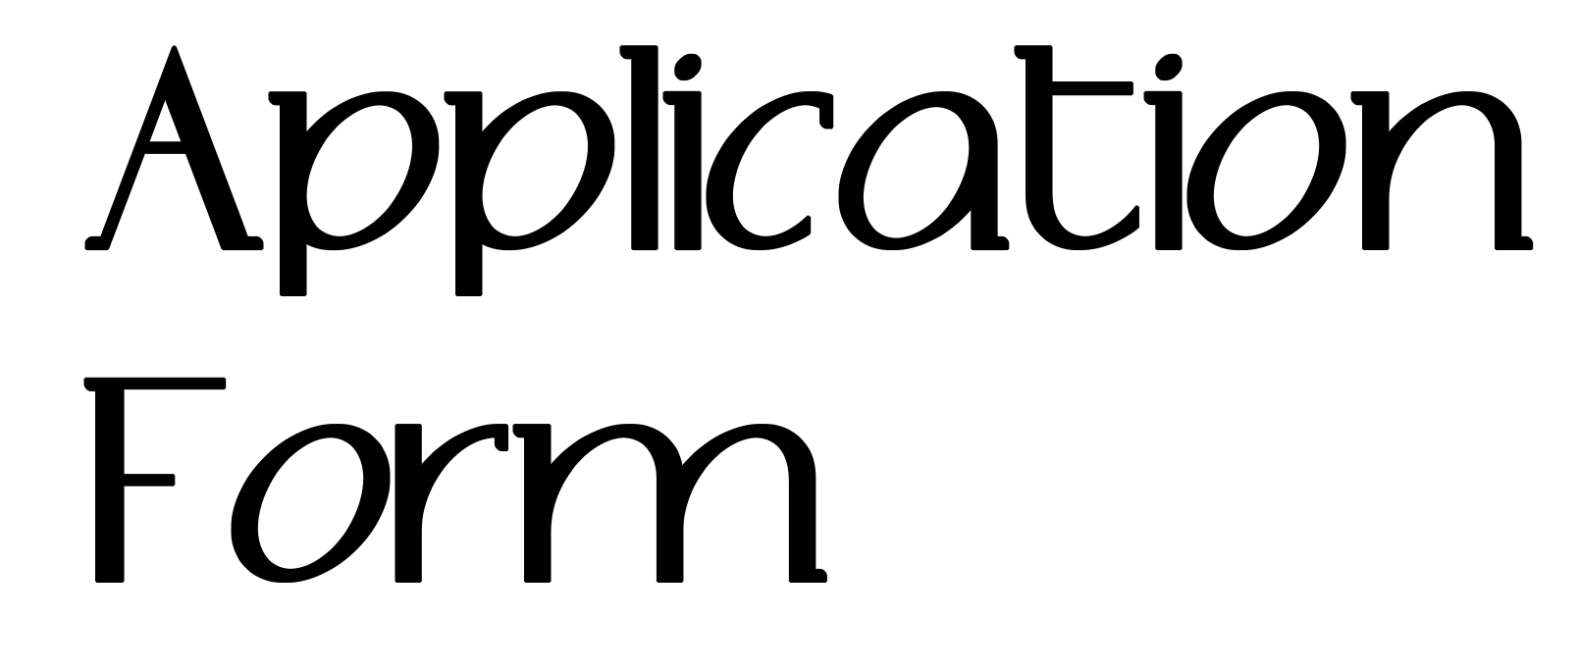
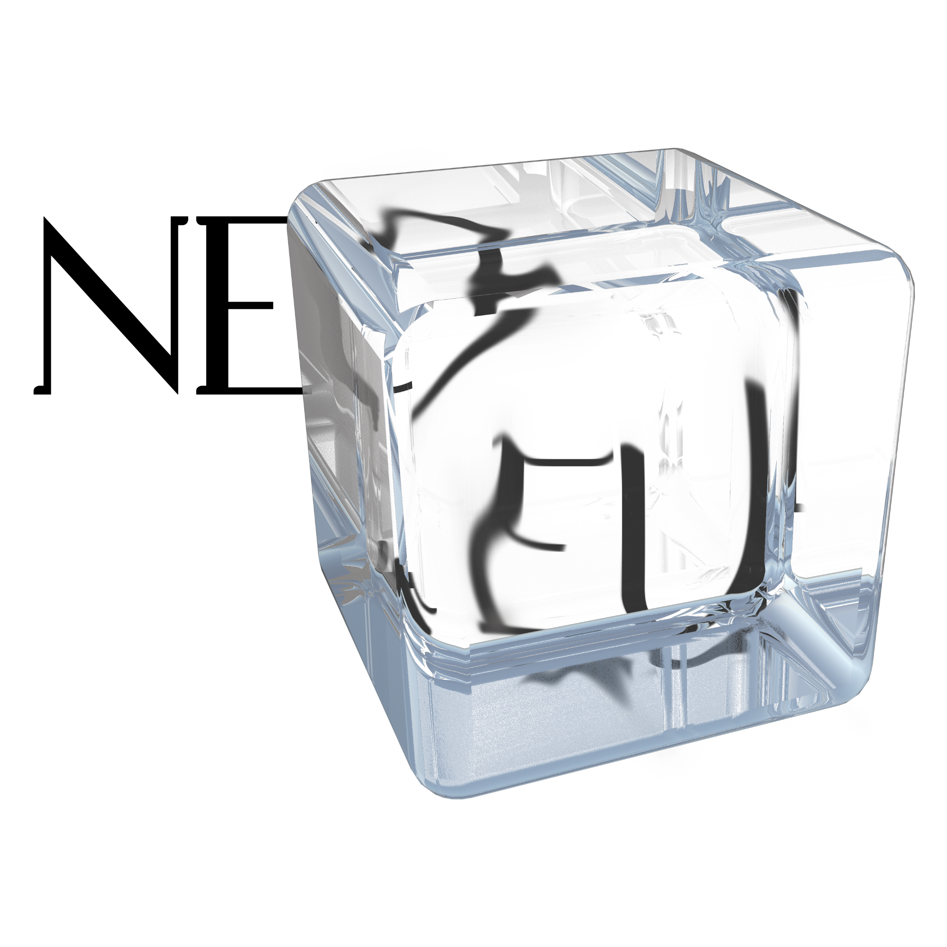

APPLICANT INFORMATION

▶ Full Name *
First Name Last Name

▶ E-Mail Address *

▶ Phone Number *

▶ Address *

ARTWORK INFORMATION

▶ Artwork Name *

*

Optional

Optional

▶ Location of Project

Optional

▶ Applying Category *

▶ Entry Descriptions (Maximum 600 characters)

▶ Main Image * (Paste the image directly)
-

